**Name:______________________________ Date:________ Hour:_____**

B2.1A *Explain how cells transform energy (ultimately obtained from the sun) from one form to another through the processes of photosynthesis and respiration. Identify the reactants and products in the general reaction of photosynthesis.*

B2.1B *Compare and contrast the transformation of matter and energy during photosynthesis and respiration.*

**Photosynthesis & Aerobic Respiration Guided Inquiry Activity**

According to the law of conservation of mass, matter cannot be created or destroyed. However, matter may be rearranged. According to the first law of thermodynamics, energy cannot be created or destroyed. However it can be transformed from one form to another. The model below represents the process of taking the sun’s energy and transforming it into chemical energy. This process is called photosynthesis.

Reactants

Products

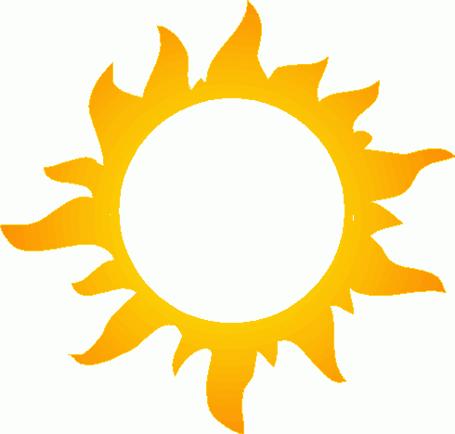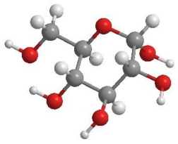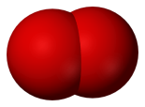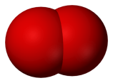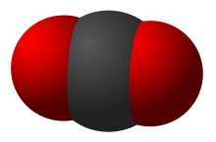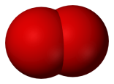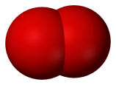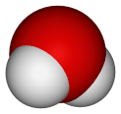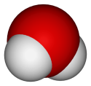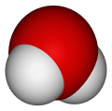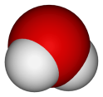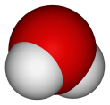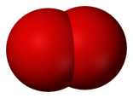

Yields

**Key**



Water (H2O) Oxygen gas (O2)

Oxygen - Red

Hydrogen – White

Carbon – Gray



Carbon Dioxide (CO2) Glucose (C6H12O6)

**Questions for Model 1**

1. How many atoms of oxygen are on the **reactants** side of the reaction?

2. How many atoms of oxygen are on the **products** side of the reaction?

3. How many atoms of hydrogen are on the **reactants** side of the reaction?

4. How many atoms of hydrogen are on the **products** side of the reaction?

5. How many atoms of carbon are on the **reactants** side of the reaction?

6. How many atoms of carbon are on the **products** side of the reaction?

7. How many molecules of water are needed for photosynthesis?

8. How many molecules of carbon dioxide are needed for photosynthesis?

9. How many molecules of oxygen gas are produced during photosynthesis?

10. How many molecules of glucose are produced during photosynthesis?

11. Use the information in Model 1 to fill in each box below with the correct number of each molecule.

___ H2O + ___ CO2 🡪 ___ C6H12O6 + ___ O2

Read This!

Glucose is the main source of energy for living things. The energy is stored in the bonds that hold the atoms together and is released when the bonds are broken or rearranged. Many living things release carbon dioxide into the atmosphere as they break down glucose in a process called cellular respiration

12. Whatatmospheric gas provides the carbon needed to produce glucose?

13. How does this gas get released into the atmosphere?

14. Why do you think photosynthesis is considered an *energy conversion* reaction?

14. List three ways that humans might benefit from the process of photosynthesis?

**Model 2**

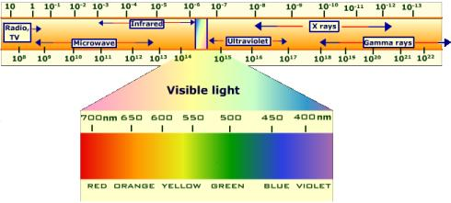

**Figure 1: Electromagnetic Spectrum**

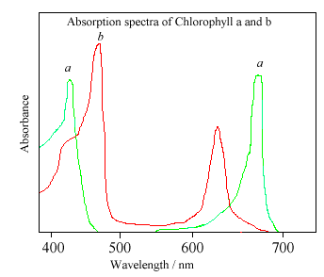

**Figure 2: Absorption spectrum for chlorophyll**

**Questions for Model 2**

1. What color of light has a wavelength of 700nm?

2. At what two wavelengths does chlorophyll “a” absorb light the best?

3. What two colors of light are used best by chlorophyll “a”?

4. What color of light does chlorophyll “a” not use at all?

5. In what organelle would you find chlorophyll?

6. Pigments are defined as substances that interact with light to absorb only certain wavelengths. Explain why you think chlorophyll should be considered a pigment.

7. Many plants contain pigments other than chlorophyll. What do you think is their purpose?

**Staying Alive**

**Energy for Life: Guided Inquiry Activity**

**Name(s): ________________________________________**

**Model 1**

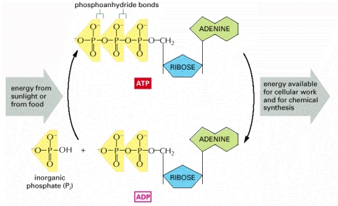 **Figure 1: ATP 🡪 ADP Cycle**

Questions

1. Why do cells need ATP?

2. What part of the ATP molecule is lost (or is broken off) in order to provide this energy?

3. What source of energy is used to create ATP from ADP?

4. Muscle cells usually have enough ATP for a few seconds of activity. As muscle cells do work, they use up their supply of ATP and have to make more. The dietary supplement Creatine Phosphate increases the capacity of muscles to do work. However, Creatine Phosphate does not actually contain ATP, it only contains phosphates. Explain how Creatine Phosphate allows muscles cells to work longer.

**Model 2**

**Read This!**

Glucose is an example of a simple carbohydrate known as a monosaccharide (simple sugar). Glucose is the primary energy molecule for many living things. Plants store glucose by stringing them together to form long chains called starch. Animals store glucose in branching chains called glycogen.

**Figure 2: Structural Formula for Glucose**



1. What molecule is shown in the diagram above?
2. Where is energy stored in this molecule?
3. What is the chemical formula for this molecule?
4. Indentify a food you think contains this molecule?
5. Which molecule has more energy, a molecule of glucose or a molecule of starch? Explain your answer.

**Model 3**

**Read This!**

The energy in glucose can be extracted most efficiently through an aerobic (with oxygen) process known as cellular respiration. Cellular respiration has three important steps known as glycolysis, the krebs (citric acid) cycle, and the electron transport chain. The last two stages of this process take place in the mitochondria. The cell must invest 2 ATP to begin the process but the investment more than pays for itself.

Figure 3: Chemical Formula for Aerobic Respiration

6O2 + C6H12O6 6CO2 + 6H2O + 36 ATP

1. What type of respiration is shown in the equation above?
2. If you start with one glucose molecule, how many ATPs does this type of respiration produce?
3. In what organic molecule is the energy to make these ATP originally stored?
4. Explain why this reaction is considered aerobic.
5. In what eukaryotic organelle does this reaction occur?
6. During aerobic respiration, 38 ATP are actually made, but only 36 net ATP are available to do work in the body. Explain why you think this is so.
7. *Saccharomyces cerevisae* is the variety of yeast used during wine making. This yeast species lives in the soil and on the grape vines themselves. As soon as the grapes are harvested and crushed, the yeast goes to work using the sugar in the grapes for energy. During this process, the juice is changed into wine. However, winemakers especially dread an aerobic bacterium called *Acetobacter*. These bacteria consume the alcohol, turning wine into vinegar. Explain how winemakers could prevent their wine from turning into vinegar.

**Model 4**

**Read This!**

When oxygen is not present, cells can still extract energy from glucose. Many cells, including human muscle cells can use the anaerobic (without oxygen) pathway known as lactic acid fermentation. Other organisms, such as yeast, can use alcoholic fermentation. These pathways produce much less ATP than cellular respiration. In animals, fermentation can only supply momentary energy and cannot meet long term energy demands.

**Figure 4: Equations for Fermentation**



1. If you start with one glucose molecule, how many ATPs are made during a fermentation reaction?
2. During fermentation in yeast, what 2 waste compounds are made in addition to ATP?
3. Explain why the above reactions are considered anaerobic.
4. Notice that lactic acid fermentation can occur in human muscle cells. If humans can do fermentation, why would a person die from lack of oxygen?
5. Your family owns a bakery and has kept the same “family recipe” for bread for over 50 years. Unfortunately, customers have been complaining that your bread is too heavy and dense. Knowing that fermentation in yeast is important in the bread making process, describe how you could change the family recipe to make the bread lighter. Give reasons why this change would improve the bread.