Name:______________________________ Date:________ Hour:_____
B4.2C Describe the structure and function of DNA.
B4.2f Demonstrate how the genetic information in DNA molecules provides instructions for assembling protein molecules and that this is virtually the same mechanism for all life forms.
B4.2g Describe the processes of replication, transcription, and translation and how they relate to each other in molecular biology.
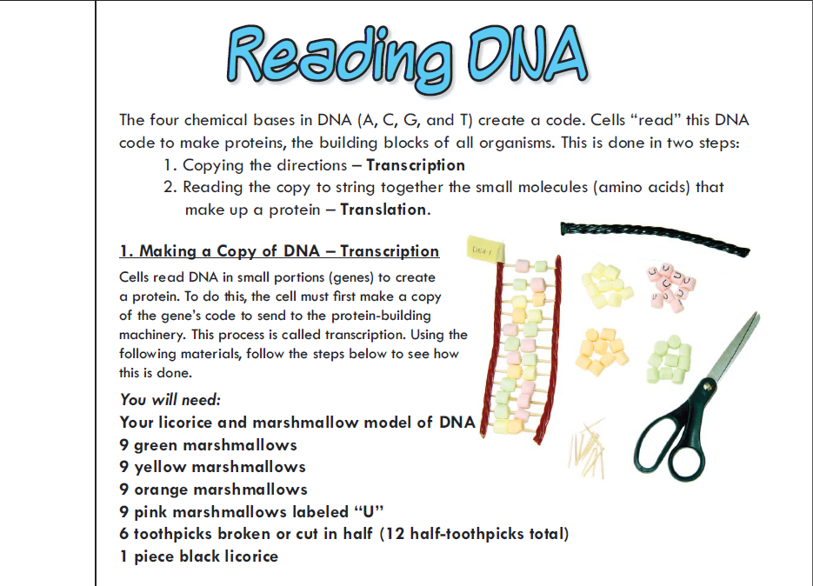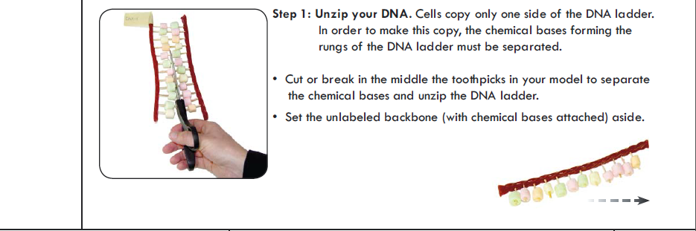

- What is your DNA sequence?

a._ _ _ _ _ _ _ _ _ _ _ _

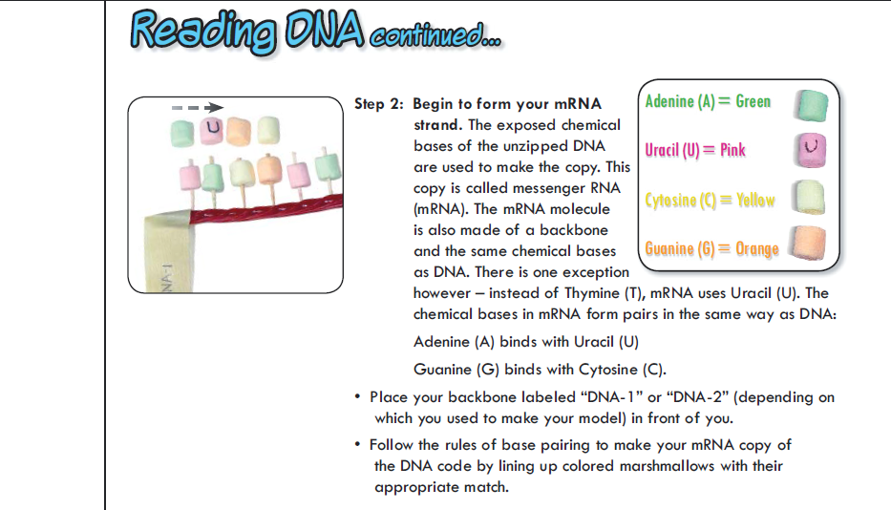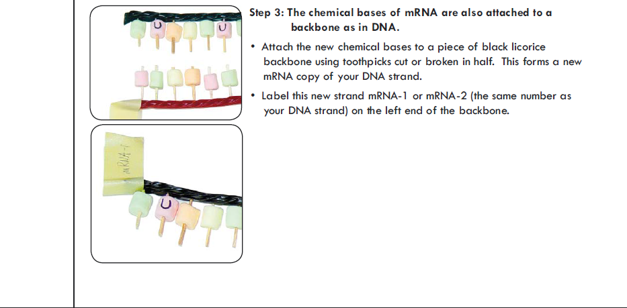

- What is your complimentary RNA sequence?

- _ _ _ _ _ _ _ _ _ _ _ _

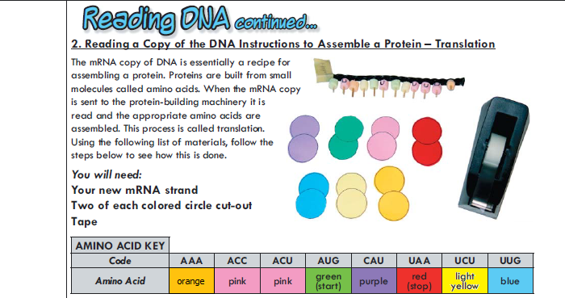
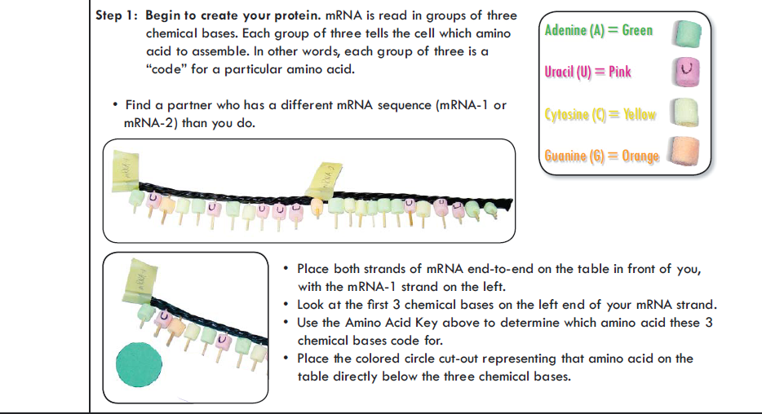

Have an instructor check your progress and have them initial below.
_______

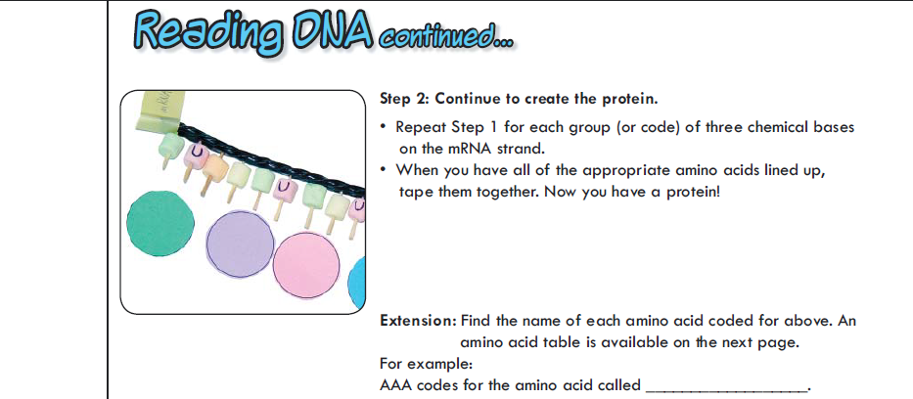

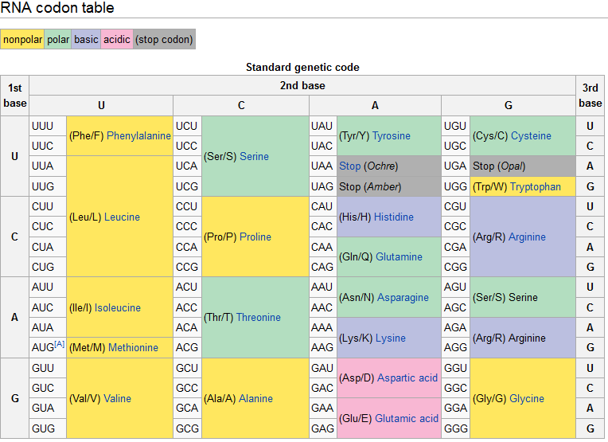

- Using the 3 letter abbreviation, what is your amino acid sequence (protein)?
- __-__-__-__-__-__-__-__

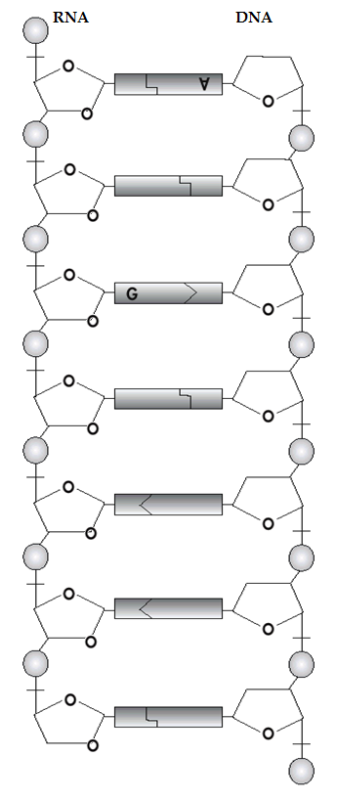

- The nitrogenous base A = ______________________________
- The nitrogenous base C = ______________________________
- The nitrogenous base G = ______________________________
- The nitrogenous base U = _____________________________
- Label each sugar group on the diagram with a letter S.
- Label each phosphate group with a letter P.
- One adenine (A) and one guanine (G) have already been labeled. Label the rest of the nitrogenous bases.

- Circle one nucleotide. What 3 things go together to make one nucleotide?
  - ___________________________________
  - ___________________________________
  - ___________________________________

- What is the term for a 3-nucleotide sequence on mRNA that codes for an amino acid? ___________________________

- In RNA, A is always paired with ______

- In RNA, G is always paired with______
- With RNA, the shape of the molecule is called a _________________________

Refer to the picture at the bottom.
- What are the differences between DNA and RNA?

